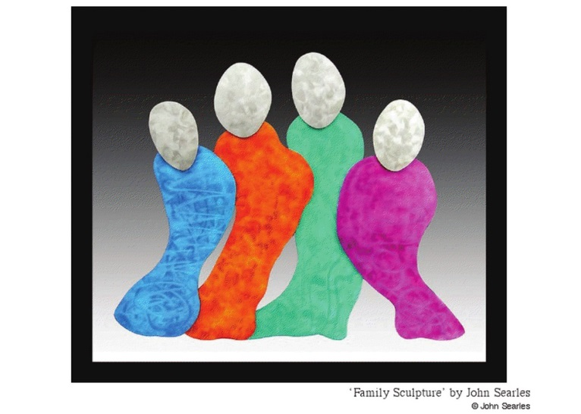
Techniques for Analysing a Visual Text

A list of techniques when analysing a visual text.
Angle | See Framing.
Body language and gaze | Facial expressions, gestures, stance or position – can convey the attitude, feelings or personality of the individual shown. Take note of the direction of the subject’s eyes.
Composition | What is included is deliberately placed (also applies to what is omitted). Consider all inclusions and omissions e.g. surroundings, objects, clothing etc.
Colour, Hue and Tone | In black & white images examine the use of contrast, light and darkness. In a colour image, colours are used to signify feelings and evoke a response. E.g. Red = passion, anger, hell, vitality, etc. blue = peace, harmony or coldness.
Contrast | The arrangement of opposite elements (light and dark, large and small, rough and smooth) to create interest, excitement or drama.
Framing | The same camera shots and angles relevant to film. Close ups, extreme close ups, medium shots, long shots, tilted up or down shots etc.
Omissions | What has been deliberately left out.
Orientation, Point of view | Relates to framing and angle: is the responder positioned above the image (looking down), below or at eye level?
Positioning | Consider which objects have been placed in the foreground, middle ground or background.
Rule of thirds | Divide an image into thirds from the top and sides and look at the placement of people and/or objects. An object in the top third is usually empowered whereas anything in the bottom third is disempowered.
Salience | The part that your eyes are first drawn to in the visual. Colour, image and layout determine what the salient image is.
Symbolism | The use of an image to represent one or more (often complex) ideas.
Vectors | The line that our eyes take when looking at a visual. Composers deliberately direct our reading path through the vectors. E.g. If all of the subjects are tall, long and upright our eyes follow straight vectors that lead to the top of the frame. This could make the subject seem powerful or inflexible.

